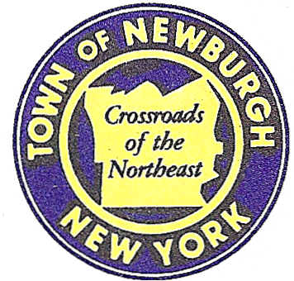

TOWN OF NEWBURGH
_______Crossroads of the Northeast __________________________
OLD TOWN HALL
308 GARDNERTOWN ROAD NEWBURGH, NEW YORK 12550

PLANNING BOARD
JOHN P. EWASUTYN, CHAIRMAN
TELEPHONE 845-564-7804
FAX 845-564-7802
E-MAIL: planningboard@townofnewburgh.org

PLANNING BOARD AGENDA

MARCH 17, 2016

*PLEASE NOTE: The Planning Board Meeting will start at 7:00 P.M. and all Applicants/Representatives
are to be present at that time. The Meeting will be held in the Meeting Room of Town Hall,
located at 1496 Route 300, Newburgh NY.*

- Restaurant Depot (2015-33) CLEARING & GRADING
NYS Route 300 PUBLIC HEARING
Section 95, Block. 1, Lot 8
Zone: IB SITE PLAN Rep: Larry Marshall, P.E.
Mercurio Norton Tarolli & Marshall
45 Main Street
Pine Bush, NY 12566

2. One Powelton Avenue (2015-19) AMMENDED SITE PLAN
Section 80, Block 6, Lot 7
Zone: B
Rep: Highlands Architecture, PLLC
3212 Route 9
Cold Spring, NY 10516

3. Bell- Pelella (16-01) 2 LOT SUBDIVSION
65 Lockwood Lane
Section 8, Block 1, Lot 4.22
Zone: AR
Rep: Sparaco & Youngblood ,PLLC
P.O. Box 818
18 N. Main St.
Harriman, NY 10926

4. Wedell Lot Line (15-27) LOT LINE CHANGES
6, 12 14 & 7 Heritage Lane
Section 89, Block 1, Lots 10.1, 10.2, 77.1 &77.2
Zone: R-1
Rep: V. Doce Associates
242 South Plank Road
Newburgh, NY 12550

